Assignment #7

Lab: HTML Text & CSS Fundamentals (20 pts.)
(Post 16 pts. | Peer Review 4 pts. | Provide coding help – 3 pts. extra credit)

Objectives:
- To practice basic HTML text formatting – headings, lists, color, size, etc.
- To implement CSS formatting
- To practice the procedure for posting documents, including CSS files to a web server

Introduction
In the first coding assignment we reviewed basic HTML markup and syntax and the procedure for uploading an HTML file to a webserver. In this lesson, we will practice text formatting and the application of CSS for additional formatting. In the second lab for this module will use HTML5 and ARIA for labeling page regions. We will use the instructions and templates provided in the Mozilla Development Network lesson HTML text fundamentals.
.
Note: although we will be implementing CSS, all the coding will be provided so you do not need to have a working knowledge of CSS to complete this assignment.
Note: as with the previous lab, if you are familiar with HTML markup and the use of CSS, this exercise may seem very basic. This is meant as an introduction for those who are new to markup and CSS syntax or need a review of these concepts.

Needed Tools
We will use the same software and tools we used in Assignment #5:
- HTML Editor (VCS)
- GitHub

One Additional Tool
Set up an account on CodePen, jsFiddle, or Glitch. (I prefer jsFiddle). These are online HTML editors (also referred to as “code playgrounds”) that allow you to test out and preview your HTML, CSS code and other web components.

Web Server Account
If you already have a web server account (i.e. on creative.colorado.edu or elsewhere), or you know how to post renderable files on GitHub (covered in assignment #6) you can continue to use your existing server but make sure to provide the URL to your work when you submit your assignments.

Instructions – formatting text with HTML & CSS
Read through the MDN lesson HTML text fundamentals
.

- Read the lesson carefully. Perform all the “active learning assignments” so that you can practice HTML markup. This will also allow you to preview how markup renders on a posted web page. (You do not need to show me this work – this is for your own practice).

- As the instructions state, if you get stuck on any of the exercises, use the “show solution.”

- When you reach the section “Test your skills!,” follow the Test your skills: HTML text basics link.

- Follow the instructions for each of the 3 HTML text basics exercises.

- To practice working with CSS, copy over the HTML code for each exercise to jsFiddle, CodePen or Glitch. (The screenshot below is from jsFiddle).

- Separate each section of code (from each assignment) with a horizontal rule (“<hr>”).

  - After you select “Run,” (in jsFiddle), you should see something similar to the following on your preview pane:

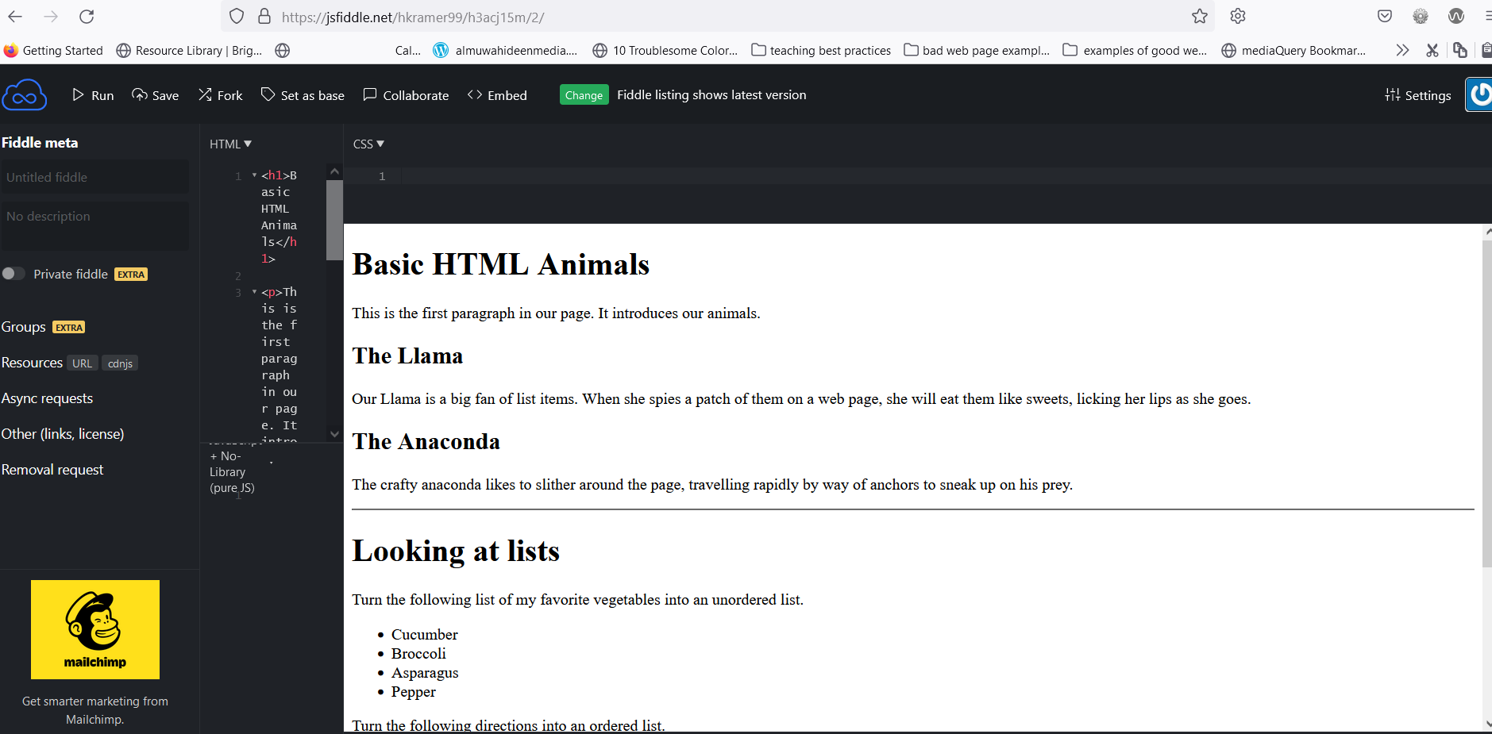

(Note the horizontal line between the first and second section of code. You should see the same between the second and third sections).

- Next, copy over the CSS code from the 3 exercises into the CSS panel in jsFiddle.

  - The code should look similar to:

h1, h2 {
color: purple;
}

p {
color: gray;
}

ul {
border: 2px solid orange;
}

ol {
border: 2px solid purple;
}

ol, ul {
padding: 5px 20px;
border-radius: 4px;
}

h1, strong {
color: purple;
}

em {
color: gray;
}

- Once you select “Run” in jsFiddle you should see something similar to the screenshot below (i.e. purple for the headings and for <strong> elements).

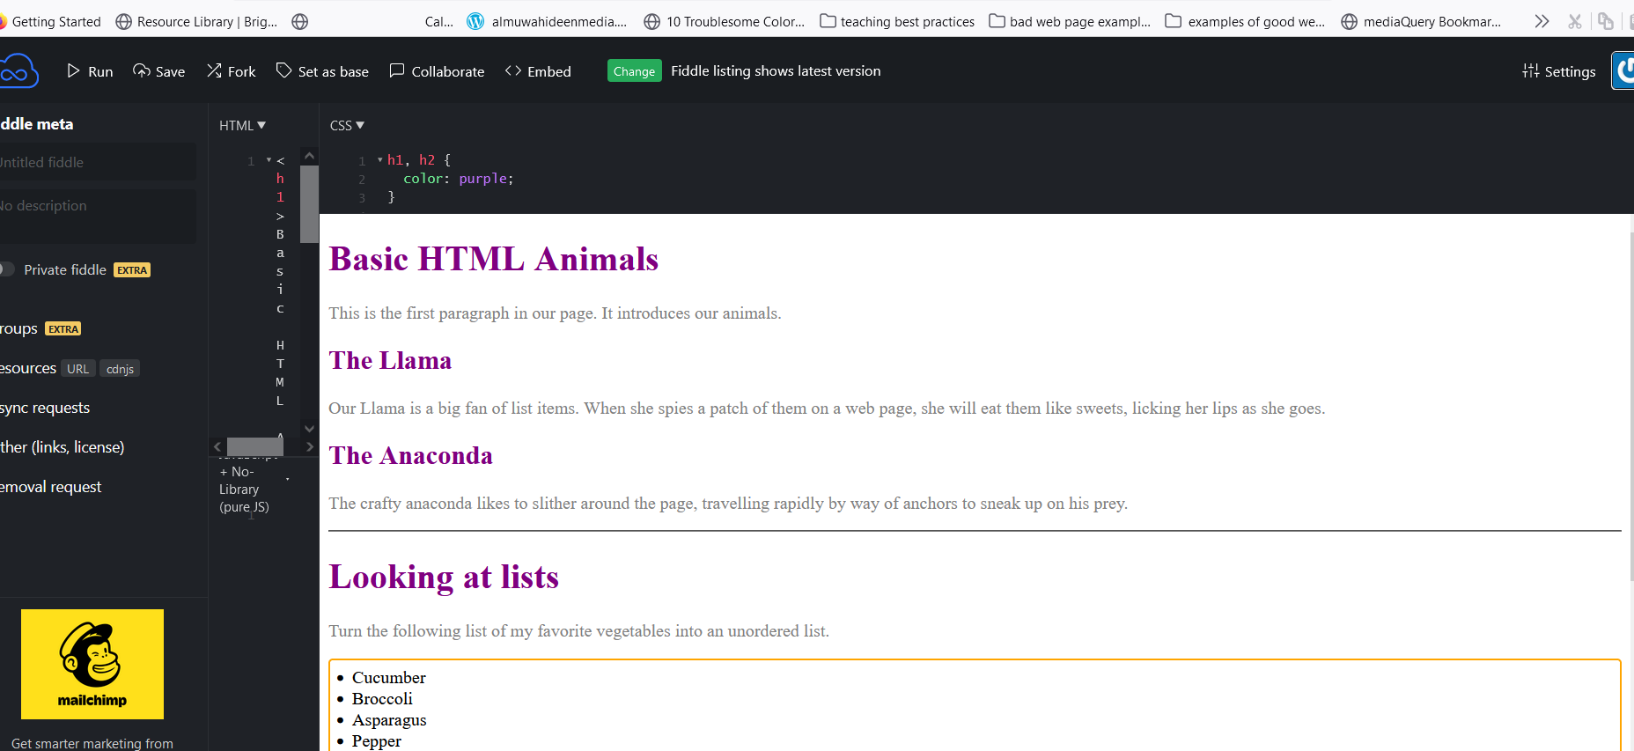

- Now try changing the color of the h1, h2 found in the first styling segment to green or another color of your choice:

h1, h2 {
color: green;
}

- Select “Run.” Have all the h1 and h2 items switched colors. If not, can you figure out why?

- Now try changing some of the other colors and other formatting in the CSS, such as the padding or border size. Make at least 3 changes to the styling.

Uploading the files to the server
- Copy both your HTML code and CSS code to two separate files in your text editor. Save the HTML code with a name such as htmlbasics.html (or a name of your own choosing) and the CSS to something like style.css.

- Similar to Assignment #5, you will need to add the HTML version information and the Header section to the document.

- In that lab, this looked like:

<!DOCTYPE html>
<html>
<head>
<meta charset="utf-8">

<title>My page title</title>
<link href="https://fonts.googleapis.com/css?family=Open+Sans+Condensed:300|Sonsie+One" rel="stylesheet" type="text/css">

<!----- Add the link to your style sheet --------->
<link rel="stylesheet" href="style.css">
<!------------------------------------------------>

<!-- the below three lines are a fix to get HTML5 semantic elements working in old versions of Internet Explorer-->
<!--[if lt IE 9]>
<script src="https://cdnjs.cloudflare.com/ajax/libs/html5shiv/3.7.3/html5shiv.js"></script>
<![endif]-->
</head>
<!-- I included the body element below which is not part of the html version or the head to make
make sure you include it above your HTML code -->
<body>

Your HTML code goes here

</body>
</html>

- Note we have added the link statement:

<link rel="stylesheet" href="style.css">

to the <head> area. This directs the browser to the location of the style sheet associated with the webpage.

- Remember to close your document with the closing </body> and </html> tags as shown above.

- Upload your two files to a new subdirectory on your server or GitHub (you can also put it in a new repository on GitHub) – something like “assign6” or “htmlbasics” is fine.

- Use the method described in Assignment #6 to determine the URL of your web page.

- Submit the URL of both your jsFiddle* (or other testing tool) work area and your uploaded page URL to the discussion indicated).

*For example, my jsFiddle work area for this assignment is at https://jsfiddle.net/hkramer99/h3acj15m/7/

- Write one or 2 paragraphs describing any problems or questions you had with the assignment. Also note any styling changes you implemented.

- Indicate if you need help with a coding or CSS issue – we will be posting this assignment to a discussion area so that the class can help each other with coding issues.

Output:

- URLs of both your jsFiddle (or other testing tool) work area and your uploaded page URL.
- Include one or 2 paragraphs describing any problems or questions you had with the assignment. Also note any styling changes you implemented.
- Indicate if you need help with a coding or CSS issue.
- Review another classmate’s work. Indicate if you see any errors with their markup or styling or have any advice or feedback on their work.
- If you help a classmate with a coding or styling issue, you’ll receive 3 pts. extra credit. You can do this for up to two classmates for a total of 6.

Submit to:
- Assignment #7 discussion area.

